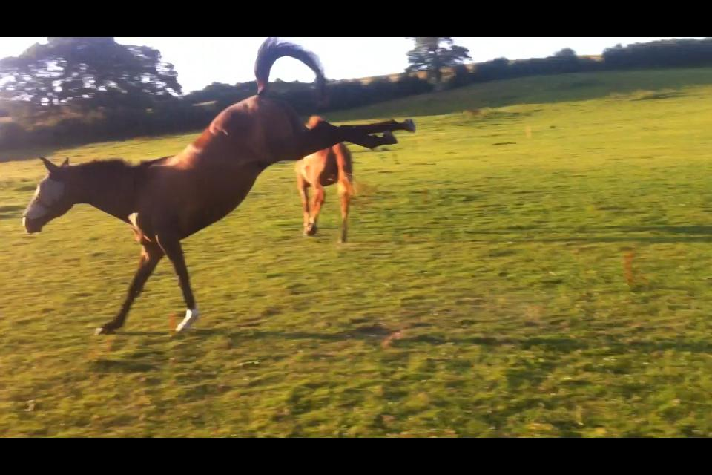
Rudgwick Riding Club Newsletter
March 2018
Dear all,

Lots to tell you this month! Welcome to new members, we hope everyone finds something to join in with in the next few months.

Our February dressage day was bitterly cold but it didn't put too many people off and a good time was had by all. Our next is on March 31st – Easter Saturday. I am moving house that weekend so cannot be there so I am really hoping a few of you can give up a few hours to help with stewarding. Please let me know in good time to avoid any stress, on my part!

Our evening at the Black Horse, an introduction to TREC, was excellent, very informative and a lovely meal afterwards. We will follow this up with a day at Rackham in the summer when we can try out the different phases on our own horses.

The show jumping clinics with Mike Lonsdale continue and everyone is enjoying them, and getting a lot from them. I think there are 3 groups this coming Sunday, so they are increasing in popularity. Do contact Julie Lee if you want to take part.
I said in the last newsletter that we were planning some flatwork/polework clinics for the spring/summer, these have now been set up to start on Wednesday 25th April at 6.30, alternate weeks with Helen Millichamp, local eventer, on polework (25/4/18, 9/5/18, 23/5/18 etc.) , and alternate weeks with Julie Lee- riding to music (2/5/18, 16/5/18, 30/5/18 etc.). This gives you options as you may like to do both and come weekly, or you may choose one and come fortnightly. Please contact me if you wish to take part.

Postponed due to the snow...now on April 3rd.

The Area 13 Quiz is being organized by Horsham Riding Club this year...

BRC AREA 13 QUIZ
AT
Dial Post Village Hall, Dial Post, RH13 8NS
On
Tuesday 3rd April 2018
At 7.30pm for a prompt 7.45 start

We have one team of 4 already but if anyone wants to be part of a second team that would be great, so please let me know.

Only 1 BHSAI or above, or PC A test (in the last 10 years) per team.

Cost £6 per head to include light refreshments. Bring your own wine!.
Our next information/social evening is at the Black Horse, Byworth again on Friday 27th April at 7 p.m.. We will have a talk given by Elliot Griffiths from Protexin, about their products and his experience as groom to Kitty King at Rio Olympic Games 2016. He will be joined by a nutritionalist from Baileys to answer all your questions about feeding your horses. As before, we will then enjoy a meal together. Please contact me if you wish to come and I will then give you details of how to order your meal.

In May we have a demonstration on bitting by Gill Batt www.horsebitadvice.com , this is at Flathurst, Petworth on Saturday 19th May from 10 a.m. to 1 p.m. Please bring a chair and £5! We will be outside but as it is in May we will probably be bathed in glorious sunshine! Please contact Jane Banner, our Social Secretary ( phone number on website) if you wish to attend.

I will send the list of competitions for Area 13 in a separate email.

Think that's all for now, ride safely,

Julia (Edwards)

contact me on 07833686492 or jheadlesswonder@aol.com

