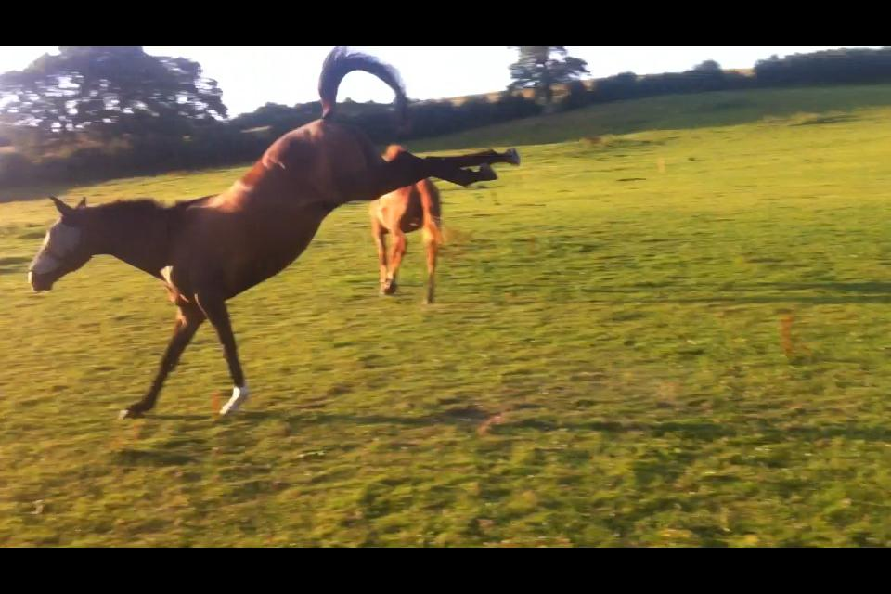
Rudgwick Riding Club Newsletter
January 2018
Dear all,

A bit belated but a Happy New Year to you all! We have gained a number of new members already, so a very big welcome to you, and to those of you who haven't renewed yet, please don't forget!
The photo is to remind us that Spring is hopefully on its way (it is actually my boy Billy, with Jimmy walking away in disgust at his juvenile behaviour), and I am looking forward to seeing grassy meadows and NO MUD! I don't think I am the only one!

Anneli Salmon is taking on organising teams, mentored by Julie Lee, so if you are keen to represent us do get in touch with her or Julie. All committee members details are on the website (Who's Who). Moira Brownson is doing a great job keeping the website up to date so please visit it!

Our January dressage day at Brinsbury went well, not so many entries but some very happy competitors. Many thanks to everyone who helped run it, we have a lot of very helpful members, for which we are very grateful.

Nearly 30 of us enjoyed a really interesting tour of Sussex Equine Hospital on Thursday 18th January, followed by a delicious meal at The White Lion in Thakeham.
Our next social event is on Thursday February 22nd at the Black Horse in Byworth, near Petworth. There is a big room upstairs. We will begin with a talk on TREC followed by a meal. Keep an eye on the website for more details but if you can let me know asap if you are coming I can let the landlord know about catering needs. The idea is to have a big pot of mild chilli con carne for everybody, let me know if anyone needs a veggie option.

We have earmarked Wednesday 14th March, at Brinsbury, for Harry Dzenis to give us a demonstration along the lines of 'getting ready for the coming eventing season', we're just waiting for Harry to confirm, so please keep an eye on the website for that too.

The show jumping clinics with Mike Lonsdale start next Sunday 4th February. Julie Lee is taking names if you want to take part.
We are also planning some flatwork/polework clinics for the spring/summer, a xc clinic at Iping and some pleasure rides.
One of our members (thank you Sarah Sawyer) suggested we do something in memory of Julie Stride, we are thinking about having an open show in the summer, which would include a members only jumping class 'The Julie Stride Challenge Cup'.

The Area 13 Quiz is being organized by Horsham Riding Club this year...

BRC AREA 13 QUIZ
AT
Dial Post Village Hall, Dial Post, RH13 8NS
On
Friday 2nd March 2018
At 7.30pm for a prompt 7.45 start

We have one team of 4 already but if anyone wants to be part of a second team that would be great, so please let me know.

Only 1 BHSAI or above, or PC A test (in the last 10 years) per team.

Cost £6 per head to include light refreshments. Bring your own wine!Payment on the night or cheques to HDRC.

Numbers please by Friday 23rd February to Carol Porter 01403 741355 or
carolporte@aol.com

Think that's all for now, ride safely,

Julia (Edwards)

contact me on 07833686492 or jheadlesswonder@aol.com

